15. Job Automation with Cronjobs

Tasks

1. Create a cronjob that runs every day at 8:00 AM and appends the current date and time to a file named mylog.txt in your home directory.

ANS:

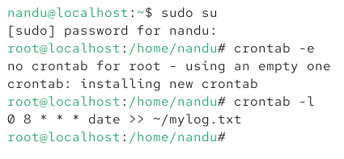

2. Set up a cronjob to back up a folder named 'music' from your Downloads directory to a 'backup_music' folder inside your Documents every Sunday at 11:30 PM. Use the cp -r command in your cronjob.

ANS:

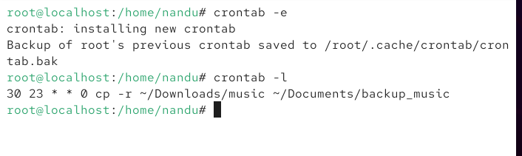

3. Write a cronjob that deletes all .tmp files from your Desktop every hour and logs the deleted filenames to a file called deleted_tmp.log.

ANS:

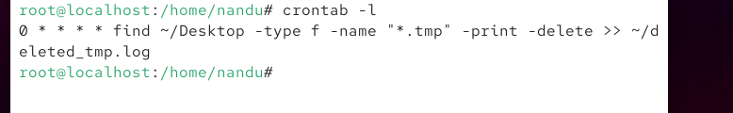

4.Temporarily disable a cronjob that prints 'Time for a break!' every 2 hours, without deleting the job. Then, re-enable it after 5 minutes. Use the comment (#) character to disable and enable lines in your crontab.

ANS:

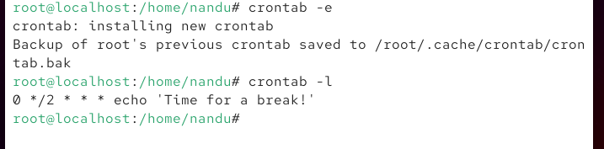

5.Use ChatGPT or another AI tool to generate a cron expression for running a script every weekday at 7:45 PM, then test it by creating a cronjob that echoes 'Dinner Reminder' into dinner.txt at the scheduled time.

ANS:

